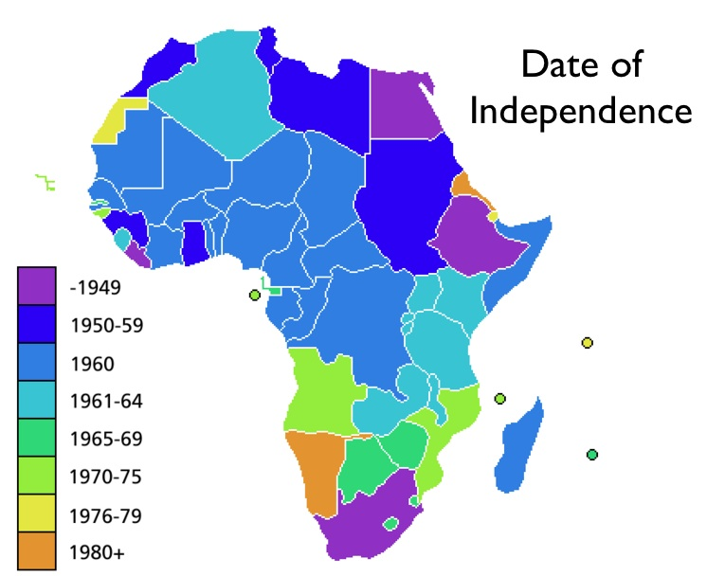

History of Africa: by Kevin Shillington -- excerpts from Chapter 28
The political legacy of colonial rule:
Many of Africa’s independence leaders had suffered periods of detention without trial for daring to speak out against the unjust and arbitrary nature of colonial authority. The boundaries of the countries themselves were mostly totally artificial. They had been created at the whim of European politicians with little or no regard to Africa’s multitude of pre-colonial nation states and small scale village communities. Peoples of widely differing languages and political and cultural traditions had been cobbled together for European convenience…These people were now suddenly expected to feel at ease with systems of multiparty parliamentary democracy that had only evolved in the nation states of Europe after centuries of conflict.
The artificiality of Africa’s national boundaries caused serious problems of nation unity after independence. African politicians may have been united in their anti-colonial sentiments, but they were yet to think of themselves as part of a single nation…most newly independent African states were plagued to a greater or lesser extent by some form of regionalism…In Chad and Sudan regional disputes have been fuelled by mutual distrust between Muslim and Non-Muslim and have flared into incessant civil war. But the vast majority of African governments have succeeded in holding their sometimes fragile states together.
The economic legacy of underdevelopment and dependency:
European colonial governments left Africa with a mounting economic crisis that had been the end product of eighty years of colonial misrule. The African economies, such as they were, had been directed towards exporting cheap agricultural raw materials and unprocessed minerals to Europe and in return, importing relatively expensive manufactured goods. There had been little or no attempt to develop African economic self sufficiency, for that would have defeated the purpose of Europe possessing colonies…Prices for Africa’s export commodities were controlled in the so-called developed economies of Europe and North America…
At the same time, as more effort was put into cash crop production and laboring in the mines, subsistence cultivation for Africa’s basic food was neglected. By the 1950’s Africa had become a net importer of food. In other words, Africans on average were growing less than half of their own food needs. The crisis was heightened by the growing level of urban unemployment. Many people migrated to the towns in a desperate attempt to escape increasing rural poverty or forced cropping and forced labor schemes….
The lack of education was a further debilitating legacy of the colonial period. Across most of tropical Africa, barely 10% of the population was literate at independence…
The early drive to economic development:
The continent’s new inexperienced rulers had high expectations of what could be achieved with political independence. But their dreams were soon shattered as the depth of the underlying economic crisis became apparent. To make matters worse, the new rulers of independent Africa made the initial mistake of modeling their development programmes upon the industrialized economies of Western Europe and North America. In this they were strongly advised by European economic ‘experts.’ The theory was simple: Europe was ‘developed’; Africa was ‘under-developed’. Therefore, to rectify the problem, Africa must copy the European model of urban centered industrialization. African leaders accepted the model because they saw rapid industrialization as the means to achieve economic self-sufficiency...early schemes for industrialization were far too ambitious and often inappropriate for the needs and resources of the country. On the other hand, Africans had to import all the expertise, technology, machinery and building materials from Europe and North America. The same applied to the improved health, education and transport facilities which Africa’s new leaders were determined to provide for their people. Within a very few years, African governments had run up huge new debts with the ‘developed’ world. The result was the need for ever greater exports of cash crops and minerals to finance the debts. The old colonial trading pattern was continued, and the adverse terms of trade got worse. The industries set up with European and American capital and expertise were those which suited Europe and America rather than Africa.

African Independence
Map Activity:
- What range of years did nations in Africa seek independence?
- What year had the most countries gaining independence?
- Why do you think the majority of nations in Africa became independent within a 5 year period?
How did rapid decolonization hurt Africa?
In the chart below, use your article to take notes on each topic.

Poverty & Conflict in Africa

If you were a leader in Africa during the time of decolonization, what would you suggest to make sure independence would lead to a strong, successful country?

______________________________________________________________________________________________
______________________________________________________________________________________________
______________________________________________________________________________________________
______________________________________________________________________________________________

