The Nuremberg Trials

The Accused of the Nuremberg Trial: Nazi Leaders Pay for the Holocaust
On October 18, 1945, the opening session of the Nuremberg Trial (also known as the International Military Tribunal) began and on November 20, the indictments were read. Though 24 men stood accused, only 21 were at the trial. (Robert Ley had committed suicide before the trial began; Gustav Krupp was considered too frail to stand trial; and Martin Bormann was missing but tried in absentia.)
Each of the accused was charged with one or more of the following:
Count I: Conspiracy to Wage Aggressive War
Count II: Crimes Against Peace
Count III: War Crimes
Count IV: Crimes Against Humanity
On October 1, 1946, the judgment was read: 12 of the defendants were sentenced to death, 3 sentenced to life imprisonment, 4 given prison sentences ranging from 10 to 20 years, and 3 were acquitted.
For more complete information of what and why particular defendants were accused, be sure to click on the links in the category "Found Guilty of Counts."
Name | Position | Found Guilty of Counts | Sentenced | Action Taken
Martin Bormann  (in absentia) | Deputy Führer | III and IV | Death | Was missing at time of trial. Later it was discovered Bormann had died in 1945.
Karl Dönitz | Supreme Commander of the Navy (1943) and German Chancellor | II and III | 10 Years in Prison | Served time. Died in 1980.
Hans Frank | Governor-General of Occupied Poland | III and IV | Death | Hanged on October 16, 1946.
Wilhelm Frick | Foreign Minister of the Interior | II, III, and IV | Death | Hanged on October 16, 1946.
Hans Fritzsche | Head of the Radio Division of the Propaganda Ministry | Not Guilty | Acquitted | In 1947 sentenced to 9 years in work camp; released after 3 years. Died in 1953.
Walther Funk | President of the Reichsbank (1939) | II, III, and IV | Life in Prison | Early release in 1957. Died in 1960.
Hermann Göring | Reich Marshal | All Four | Death | Committed suicide on October 15, 1946 (three hours before he was to be executed).
Rudolf Hess | Deputy to the Führer | I and II | Life in Prison | Died in prison on August 17, 1987.
Alfred Jodl | Chief of the Operations Staff of the Armed Forces | All Four | Death | Hanged on October 16, 1946. In 1953, a German appeals court posthumously found Jodl not guilty of breaking international law.
Ernst Kaltenbrunner | Chief of the Security Police, SD, and RSHA | III and IV | Death | Hanged on October 16, 1946.
Wilhelm Keitel | Chief of the High Command of the Armed Forces | All Four | Death | Requested to be shot as a soldier. Request denied. Hanged on October 16, 1946.
Konstantin von Neurath | Minister of Foreign Affairs and Reich Protector of Bohemia and Moravia | All Four | 15 Years in Prison | Early release in 1954. Died in 1956.
Franz von Papen | Chancellor (1932) | Not Guilty | Acquitted | In 1949, a German court sentenced Papen to 8 years in work camp; time was considered already served. Died in 1969.
Erich Raeder | Supreme Commander of the Navy (1928-1943) | II, III, and IV | Life in Prison | Early release in 1955. Died in 1960.
Joachim von Ribbentrop | Reich Foreign Minister | All Four | Death | Hanged on October 16, 1946.
Alfred Rosenberg | Party Philosopher and Reich Minister for the Eastern Occupied Area | All Four | Death | Hanged on October 16, 1946.
Fritz Sauckel | Plenipotentiary for Labor Allocation | II and IV | Death | Hanged on October 16, 1946.
Hjalmar Schacht | Minister of Economics and President of the Reichsbank (1933-1939) | Not Guilty | Acquitted | Denazification court sentenced Schacht to 8 years in a work camp; released in 1948. Died in 1970.
Baldur von Schirach | Führer of the Hitler Youth | IV | 20 Years in Prison | Served his time. Died in 1974.
Arthur Seyss-Inquart | Minister of the Interior and Reich Gouvernor of Austria | II, III, and IV | Death | Hanged on October 16, 1946.
Albert Speer | Minister of Armaments and War Production | III and IV | 20 Years in Prison | Served his time. Died in 1981.
Julius Streicher | Founder of Der Stürmer | IV | Death | Hanged on October 16, 1946.
- Define the Nuremberg Trials.
- Out of the four charges Nazi’s could receive, which do you think is the worst crime these men could have committed?
- How many men were found guilty of all four counts? Where their sentences all the same? Why do you think this is?
- Do you think it was right to kill some of the men found guilty? Or, do you think killing these men is just immoral as killing the Jews? Explain your answer.

CREATION OF THE UNITED NATIONS
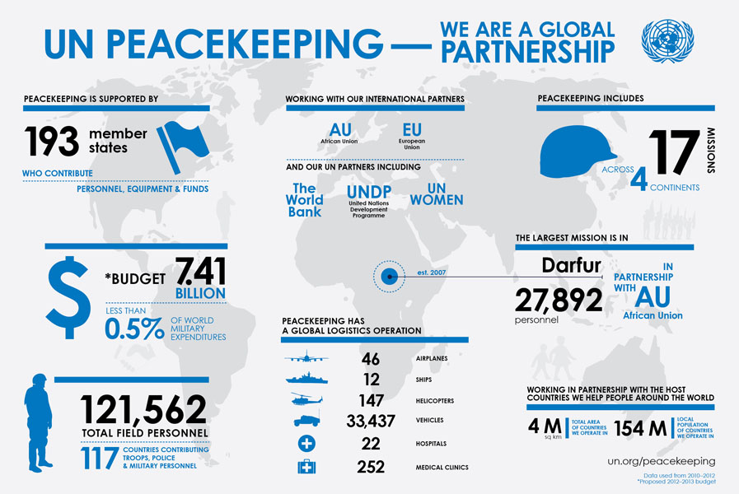
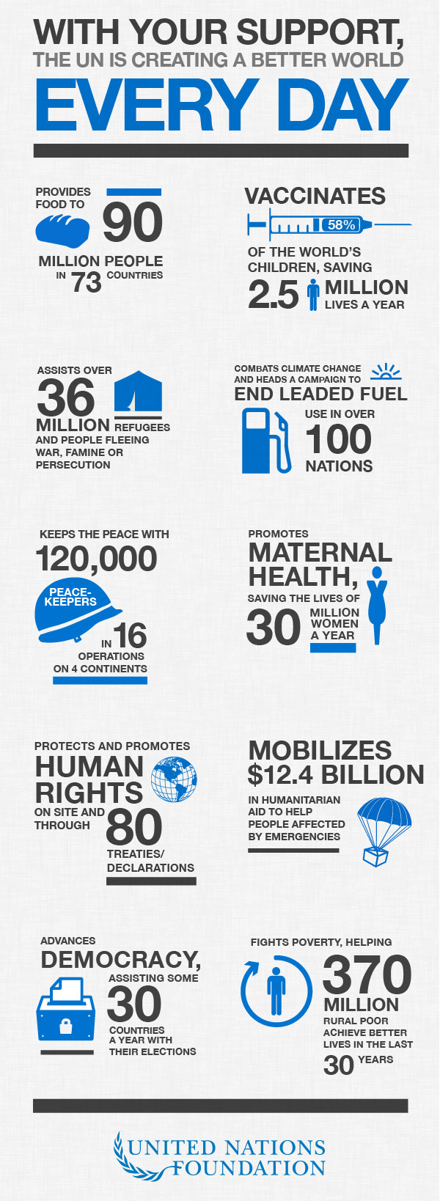
- From the infographics, what do you think is the main purpose of the United Nations?
- Where is the United Nation’s largest mission today? How many personnel are helping with this mission?
- Why do you think the United Nations was created?
- Thinking about the current events of today, do you think the United Nations is an effective organization? Why or why not?
CREATION OF ISRAEL
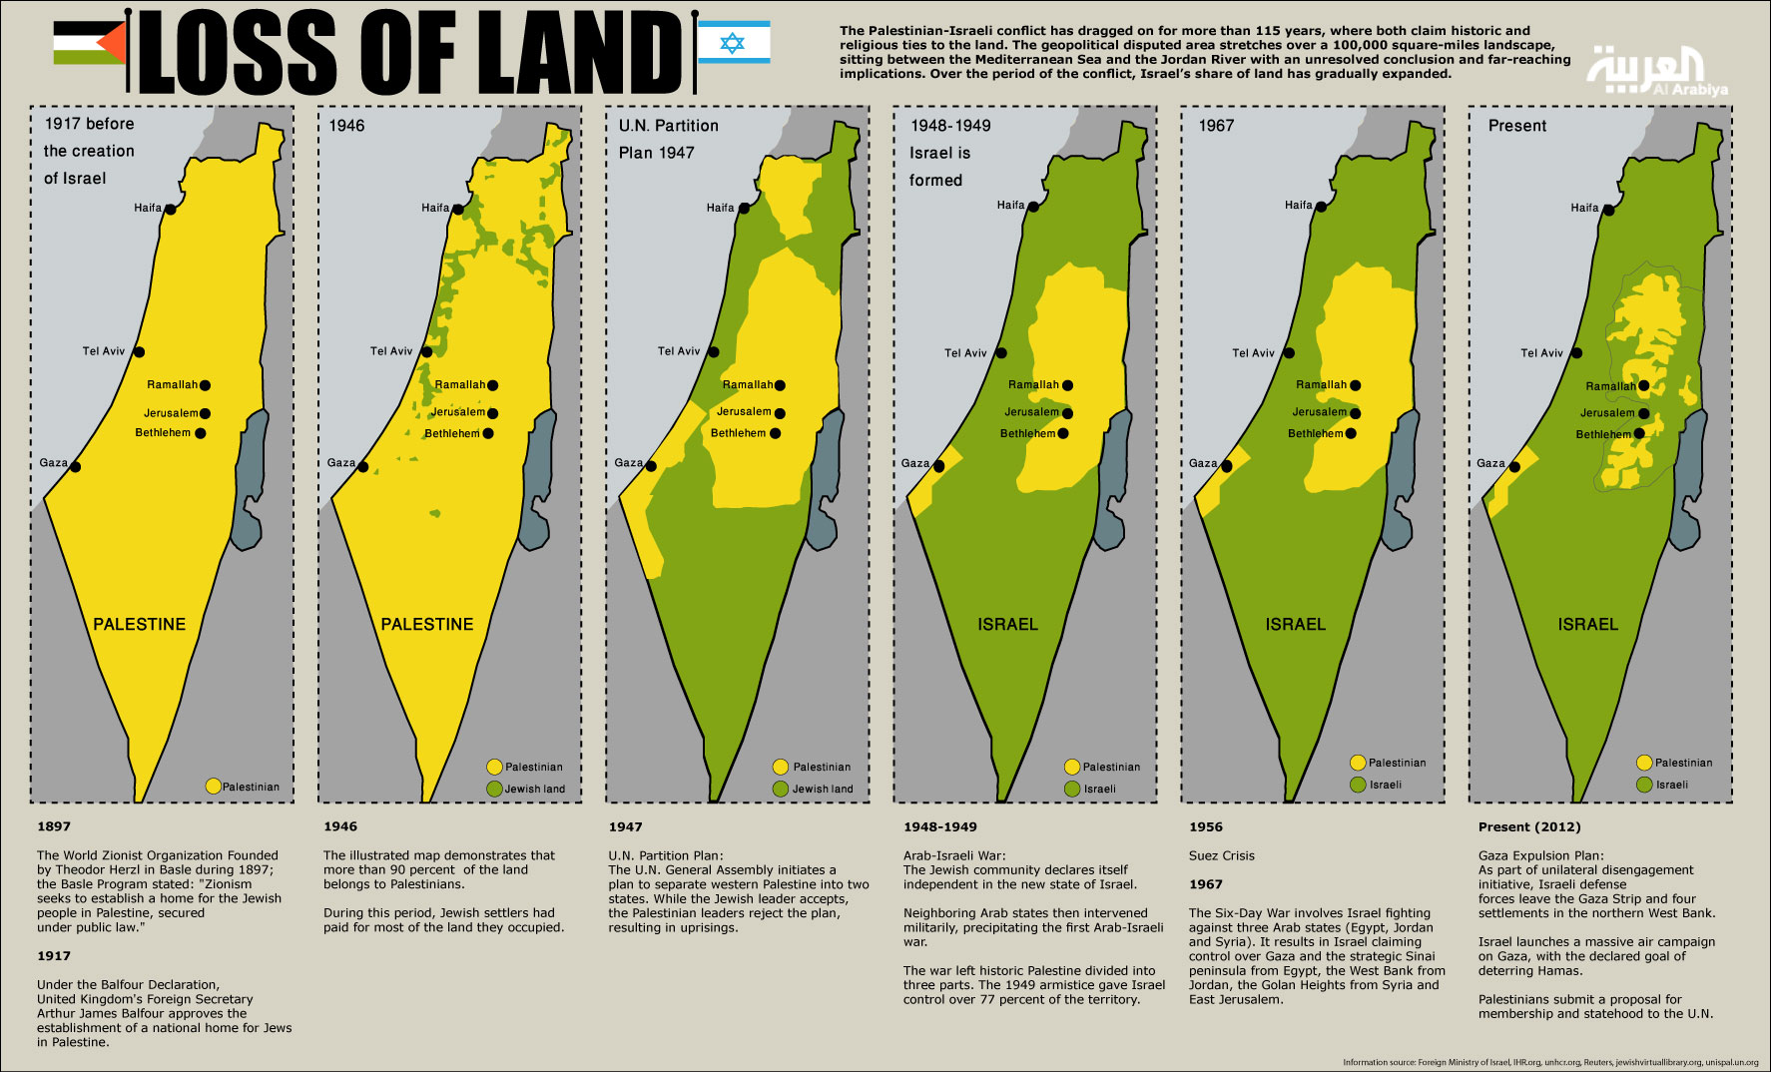
- What was the name of Israel prior to WWII?
- What international group created Israel?
- What impact did the creation of Israel have on native Arab people?
- After reading about the creation of Israel, did this group have a right to create a homeland for the Jews, why or why not?

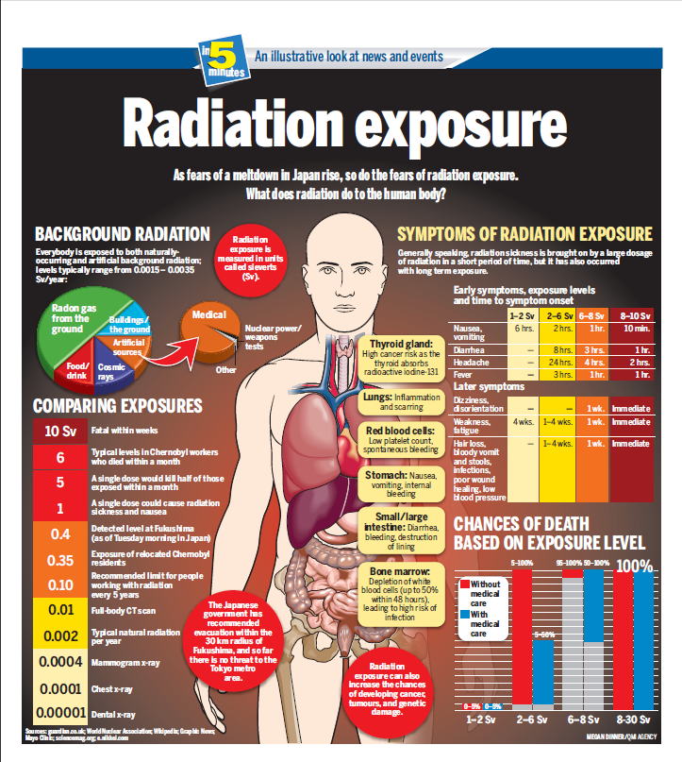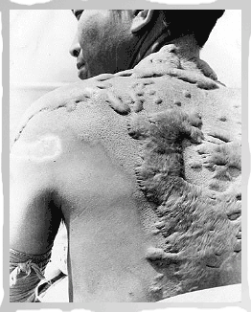

EFFECTS OF ATOMIC BOMB:

- First two weeks: mainly burns from rays and flames, and wounds (trauma) from blast and falling structures.
- - 3rd week through 8th week: symptoms of damages by radioactive rays, e.g., loss of hair, anemia, loss of white cells, bleeding, diarrhea. Approximately 10% of cases in this group were fatal.

- - 3rd and 4th months: “some improvement” in burn, trauma, and even radiation injuries. But then came “secondary injuries” of disfiguration, severe scar formations (keloids), blood abnormalities, sterility (both sexes), and psychosomatic disorders.

- - Even now, after over half a century later, many aftereffects remain: leukemia, A-bomb cataracts, and cancers of thyroid, breast, lungs, salivary glands, birth defects, including mental retardation, and fears of birth defects in their children, plus, of course, the disfiguring keloid scars.

RELATIONSHIPS AFTER WORLD WAR II:
http://www.youtube.com/watch?v=P2ayJxiQMAo

- Which two countries were new superpowers after WWII?
- Why was there tension between Stalin and other allied powers?
- What did the Marshall Plan do for Western Europe?
- Why did the Marshall Plan cause tension with the Soviet Union?
- What is the Iron Curtain?
- Who was a part of the Cold War?

EFFECTS OF WORLD WAR II:
RELATIONSHIPS AFTER WORLD WAR II:
- Why was there tension between Stalin and other allied powers?
- What did the Marshall Plan do for Western Europe?
- Why did the Marshall Plan cause tension with the Soviet Union?
- What is the Iron Curtain?
- Do you think Eastern Europe should have been a part of the communist Soviet Union, or do you believe they should have been independent, democratic countries?

CREATION OF ISRAEL:
- What was the name of Israel prior to WWII?
- What international group created Israel?
- What impact did the creation of Israel have on native Arab people?
- After reading about the creation of Israel, did this group have a right to create a homeland for the Jews, why or why not?

CREATION OF THE UNITED NATIONS:
- From the infographics, what do you think is the main purpose of the United Nations?
- Where is the United Nation’s largest mission today? How many personnel are helping with this mission?
- Why do you think the United Nations was created?
- Thinking about the current events of today, do you think the United Nations is an effective organization? Why or why not?

The Nuremberg Trials:
- Define the Nuremberg Trials.
- Out of the four charges Nazi’s could receive, which do you think is the worst crime these men could have committed?
- How many men were found guilty of all four counts? Where their sentences all the same? Why do you think this is?
- Do you think it was right to kill some of the men found guilty? Or, do you think killing these men is just immoral as killing the Jews? Explain your answer.

EFFECTS OF THE ATOMIC BOMB:
- List at least three symptoms of radiation exposure.
- What effects showed up in victims of the atomic bomb weeks after the attack?
- What health problems still show up in areas affected by the atomic bomb?
- Was it a good thing for the United States to bomb Japan and end WWII or not? Why?

