1st Stop: West African Villages
Carefully examine each picture and read the paragraph below. Then, as a group, discuss the following questions. One person should record your answers.

- What emotions do you see in these pictures?

- How can you tell some men are supervisors?

- Why are these supervisors not white?

- In conclusion, what do you believe is happening in these pictures?

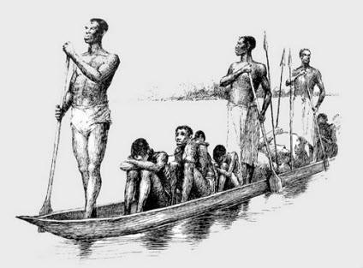
http://www.p-rr-tt.org.uk/Family%20Notes%20June08htm.htm

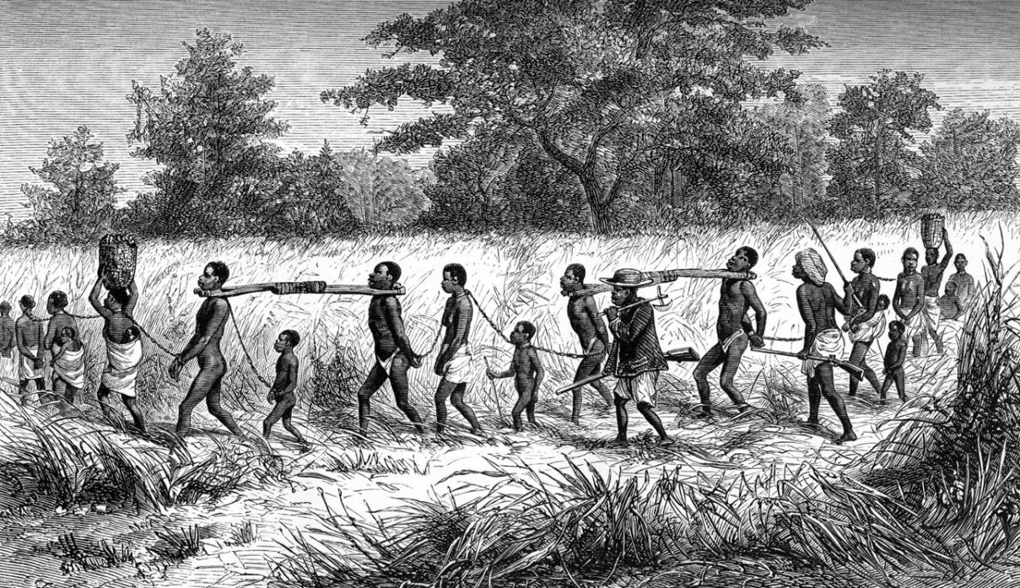http://libweb5.princeton.edu/visual_materials/maps/websites/africa/livingstone/livingstone-images.html

2nd Stop: Trading Post/ Cape Coast Castle
Carefully examine each picture and read the paragraph below. Then, as a group, discuss the following questions. One person should record your answers.

- What was your first impression of the Cape Coast Castle?

- Why is this trading post located on the coast?

- How can you tell this trading post was built by Europeans?

- At this point in the journey, what would you be feeling if you were one of the captured slaves?

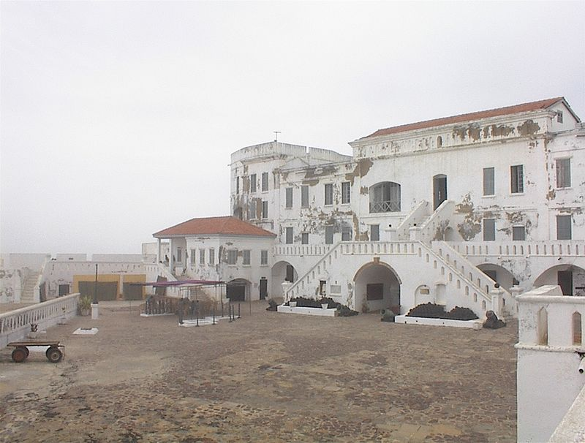
http://www.ask.com/wiki/Ghana

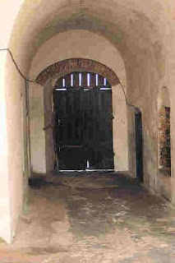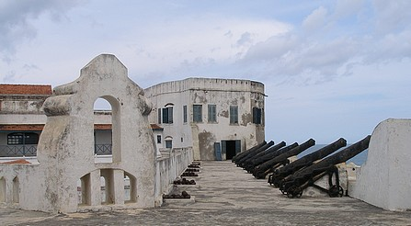
http://siku-moja.blogspot.com/2009/07/cave-of-no-return-cape-coast-castle.html

Europeans set up trading posts to trade manufactured goods for the natural resources of Africa. The one pictured above was located in Ghana and called the Cape Coast Castle. Eventually, these sites became places to house thousands of slaves who awaited their dreaded journey to the new world. Around 1000 male slaves and 500 female slaves occupied the castle at any one time in separate dungeons. Each slave would be locked up for 6-12 weeks, waiting for their turn to board one of the ships. The dungeons must have been unbearable with hundreds of slaves crammed in together and no toilet facilities. The picture above (to the left) is a picture of “The Cave of No Return” where slaves would exit the trading post and board their ships.

3rd Stop: Middle Passage
Carefully examine each picture and read the paragraph below. Then, as a group, discuss the following questions. One person should record your answers.

- What was your first impression of the Middle Passage?

- Why were slaves beaten during the Middle Passage?

- With that many people in such a small area, what types of problems do you think occurred?

- If you were on the Middle Passage, how would you cope with the conditions?

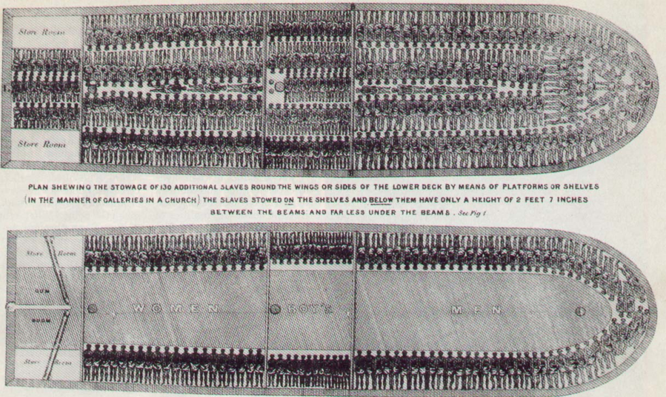

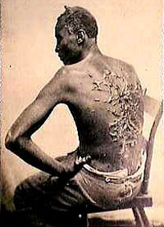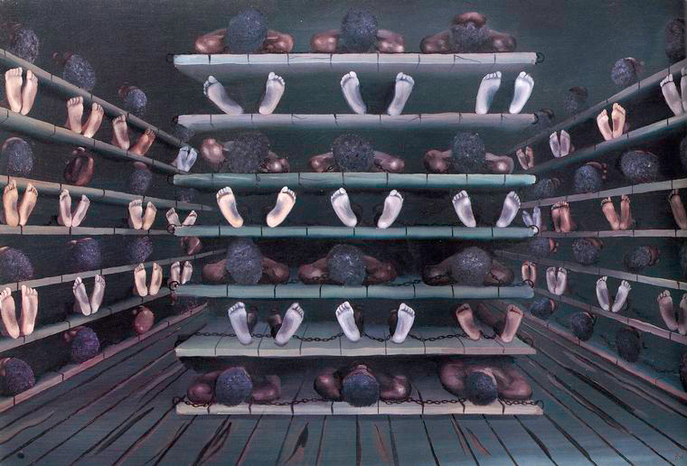

The Middle Passage was the journey from Africa to the Americas. Ship captains were known as “tight packers” or “loose packers” depending on how many people they were willing to fit on a ship. Most ships held 400, but it was not unusual to have 600-700 people per ship. People were treated as cargo. The trip would take nearly 50-90 days. Due to their packed conditions, Africans would have to lie in each others sweat, urine, feces and blood. The heat was unbearable and un-breathable.

Many people would refuse to eat or even commit suicide. The ship’s crew would brutally force the slaves to eat so that they would not die, because if someone died, they could not be sold for profit. The slaves would often be beaten with a device called a cat-o-nine-tails, which would leave horrible wounds on the slaves.

4th Stop: Slave Auction
Carefully examine each picture and read the paragraph below. Then, as a group, discuss the following questions. One person should record your answers.

- What are these images communicating? / What is the purpose of these images?

- Where would these images be found?

- Note the color of the man by the stage in the picture below. How could he have gotten a job at a slave auction?

- What was the purpose of the Transatlantic Slave Trade?

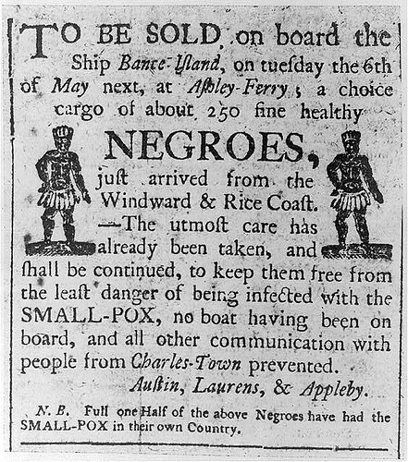
http://www.learnnc.org/lp/editions/nchist-newnation/4382

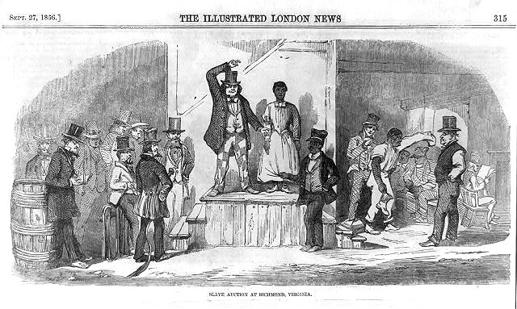

Journey From Africa to the Americas

Triangular Trade:
- The Triangular Trade is a historical term indicating ___________________ specifically, Africa, Europe and the Americas.

What caused the Triangular Trade?
- Natural resources: _______________________________________________________________
________________________________________. Examples include oil, coal, water, and land.
  - Africa had resources that could be traded with other nations, such as gold & silver, but they were lacking ______________________ that England and the New World could provide. This created a trading system between the three continents.
  - Pretty soon, European countries such as Great Britain, Portugal, France and the Netherlands began establishing ___________________________________________________________
___________________________________. (which is now America)
  - This gave Europeans access to natural resources that created great wealth… …however, while the European countries were becoming more and more wealthy, Africa was being stripped of resources… human resources.
- Need for labor: There was an incredible need for ____________________ to help build and pioneer this New Land.
  - Also, there was a need for ______________________________ so that additional natural resources, such as sugar, molasses and tobacco could be traded with Europe.

Both natural resources and the need for labor fueled the “Scramble for Africa,” or the colonization of Africa and the New World.

The Transatlantic Slave Trade
- The need for labor created the beginning of the ____________________________________, where millions of Africans were sold by African tribes or captured into slavery and sold for a massive profit.
  - Slaves could be bought for $20 and sold in the Americas for up to $120 dollars.
- Eventually, the demand for labor was so strong Europeans ____________________________________
__________________________, but began capturing Africans against the will of the African people.
- Surprisingly, slavery was ______________________________. Various kingdoms would force people into labor.
  - However, the number of slaves skyrocketed when Europe began exploiting Africa.
  - Nearly ____________________________ were sold into slavery.

GROUP ACTIVITY: provide a description of each “stop” a captured slave had to go through. In your group, one person needs to record your answers from the questions provided on a separate sheet of paper.

- 1st Stop: Captivity

- 2nd Stop: Cape Coast Castle/Trading Post

- 3rd Stop: The Middle Passage

- 4th Stop: Slave Auction

Effects of the Transatlantic Slave Trade
- ___________________________ African people were sold into slavery leaving a significant portion of African without its strongest men
- Families were torn apart
- European colonies thrived and were extremely wealthy while Africans were exploited and lost great wealth
- Probably the most lasting effect is ________________.
  - European nations tried to use science to prove that Africans were in some way “less than human”, or an inferior race to justify their harsh treatment and enslavement of Africans
  - Even today some racism remains
- To combat the negative feelings of racism, African American leaders began a movement for all people with African ancestry to be joined together regardless of ethnic group, economic status, and cultural differences.
- •This movement was called and its purpose was to unify Africa and people of African descent.

