Maps of Africa
From Colonialism to Independence
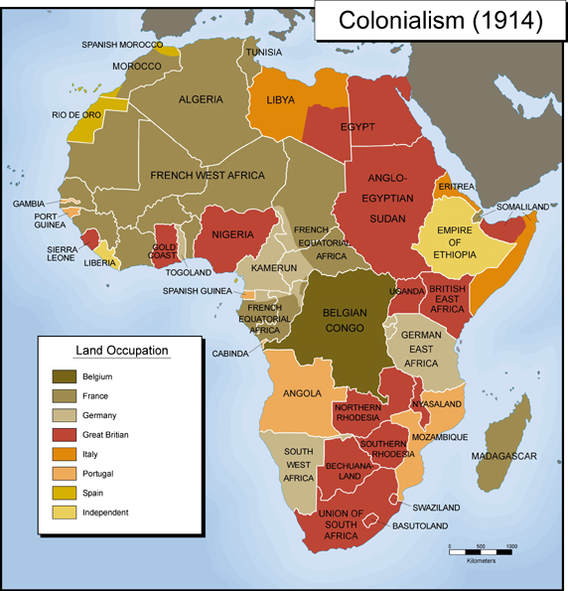
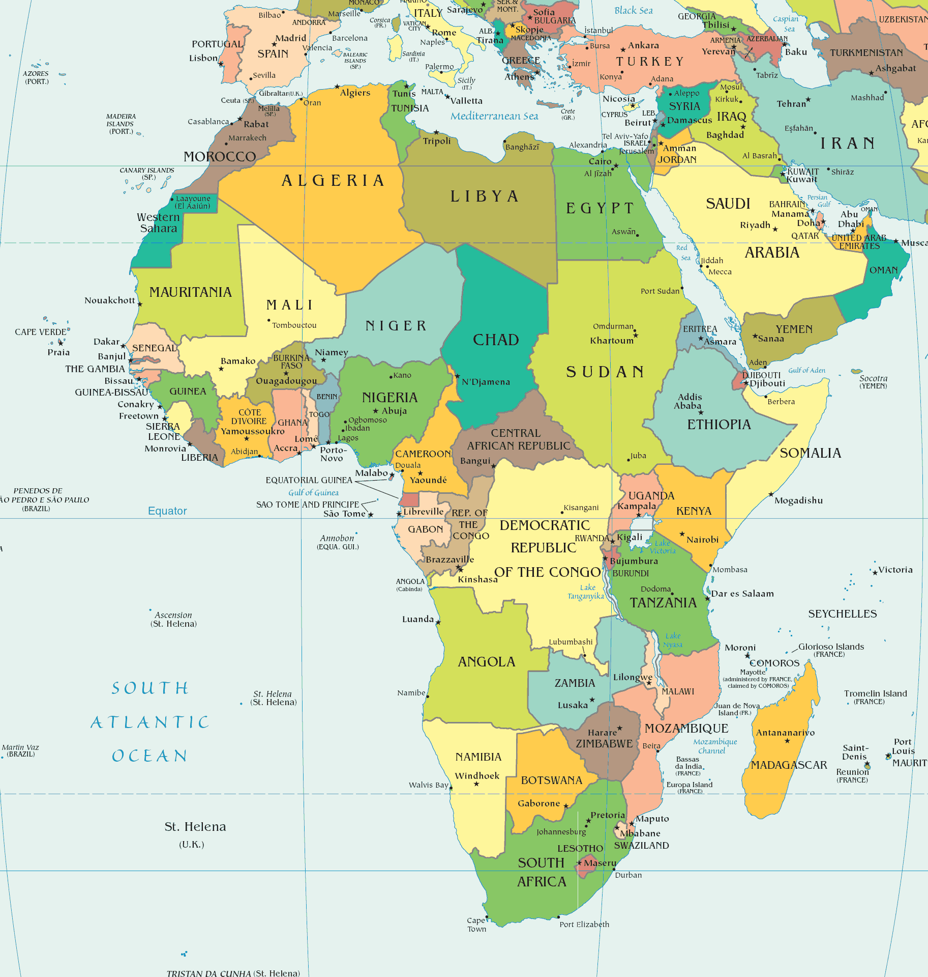
Today (2012)

How were traditional borders taken into account at the Berlin Conference?

How are these maps similar?

How are they different?

What does this tell us about the effects of colonialism on modern Africa?

