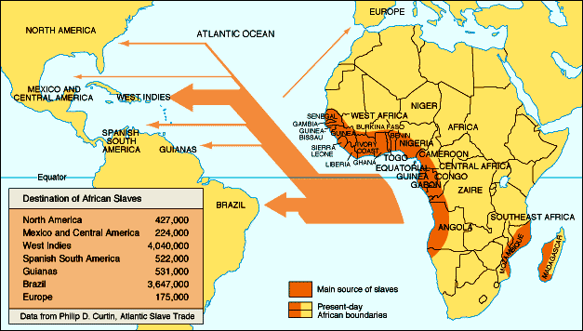
- Which continents are shown on this map?

- Which region was the source for most slaves? (be specific)

- Which 2 areas received the most slaves?

- Who provided the data for the map?

- In regards to Triangle Trade, what does the “middle passage” refer to?

- Why did North and South America want slaves?(Write at least 3-5 sentences)

