TRENCH WARFARE
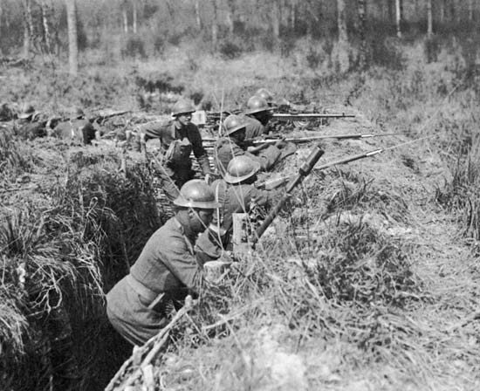

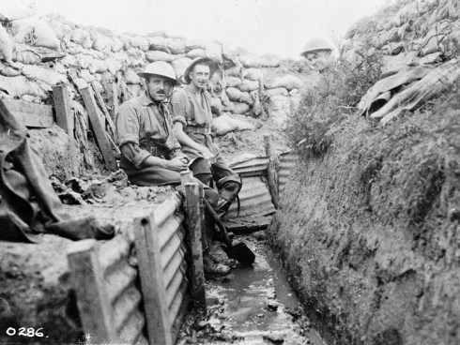

greecesocialstudies.wordpress.comkids.britannica.com
MACHINE GUNS
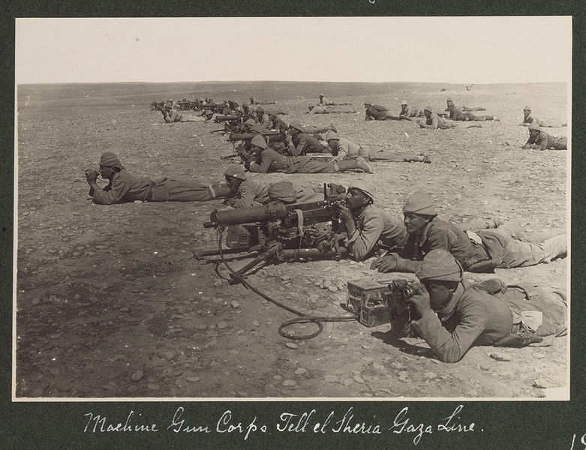

en.wikipedia.org
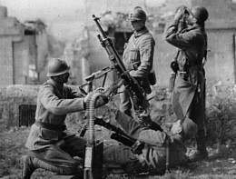

landships.freeservers.com
POISONOUS GASES
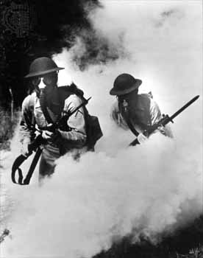

hanscomfamily.com
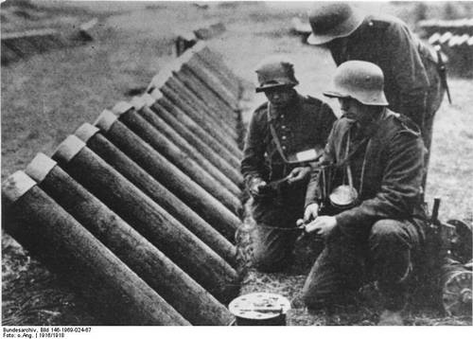

chemistry.about.com
AIRPLANES
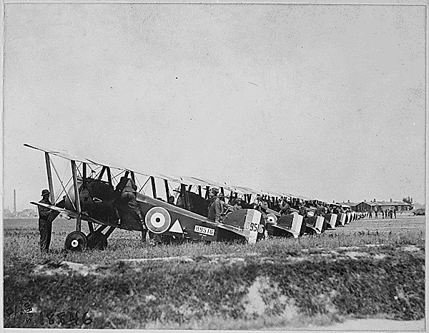

history1900s.about.com

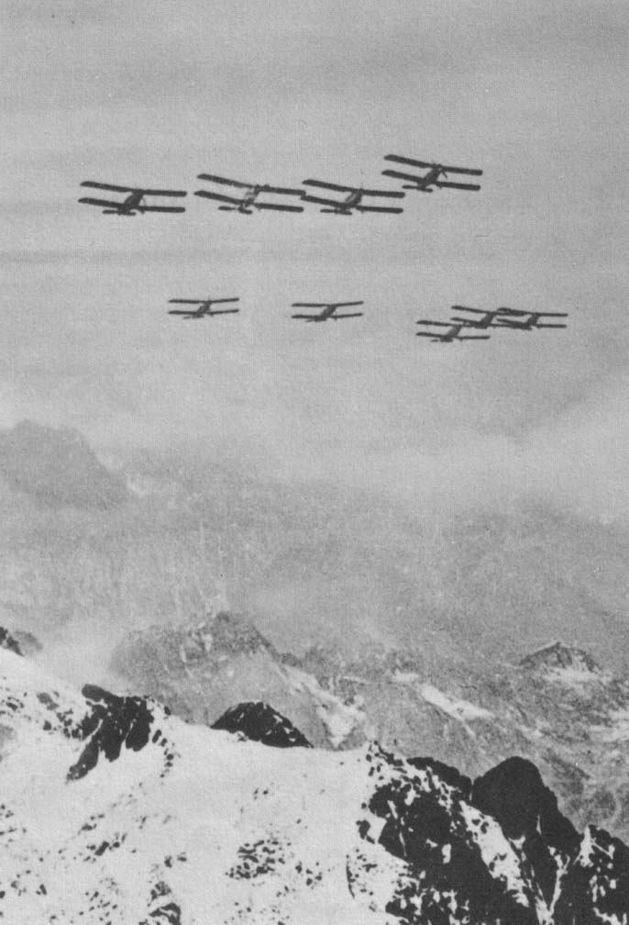

vlib.us

RAILROADS & TRAINS
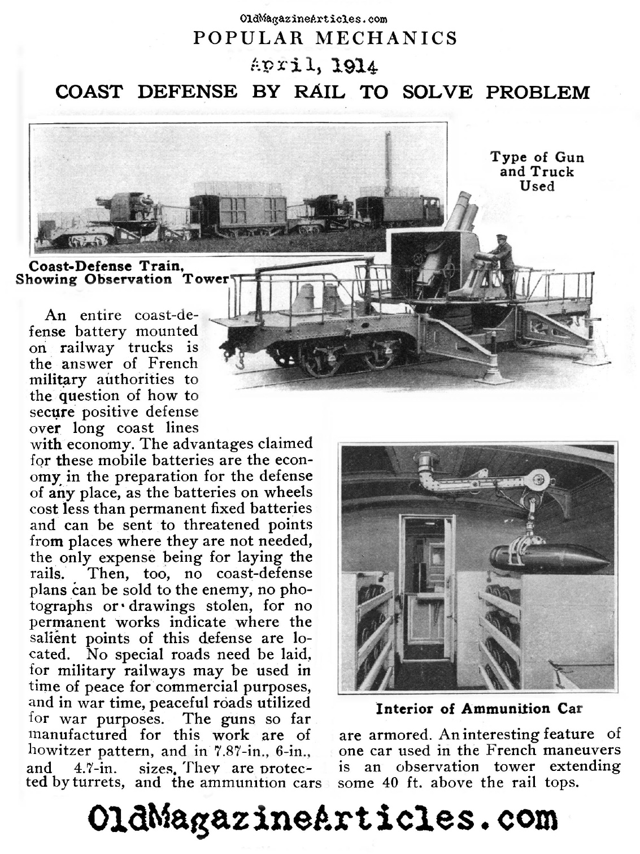

Destroyed railroad during WWI.

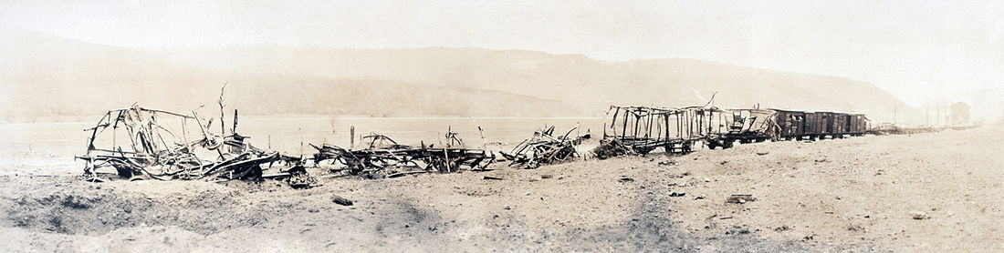

en.wikipedia.org
ARMORED TANKS

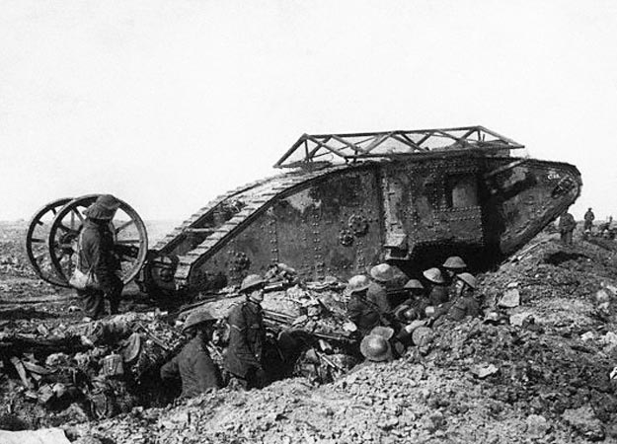military.discovery.com

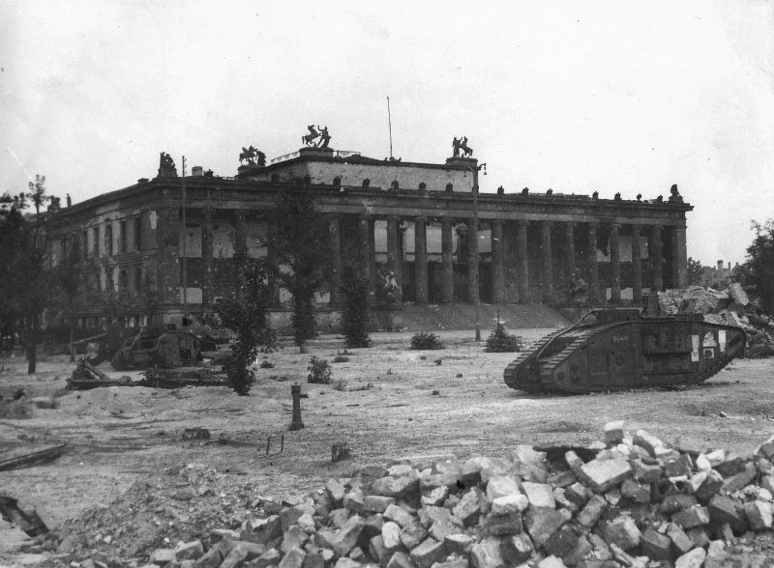
beute.narod.ru

SUBMARINES
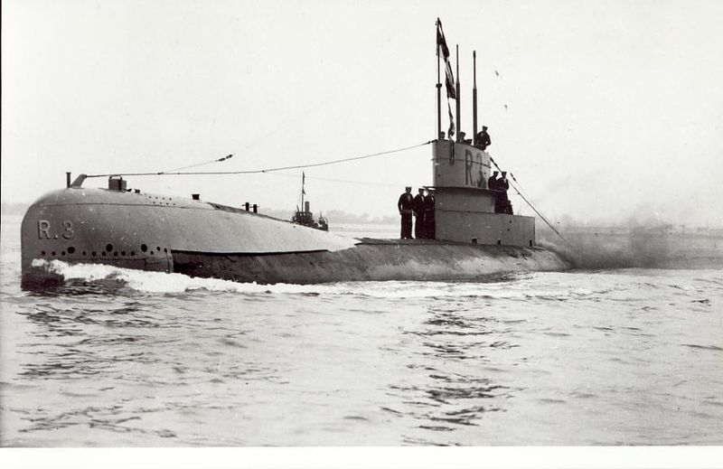en.wikipedia.org

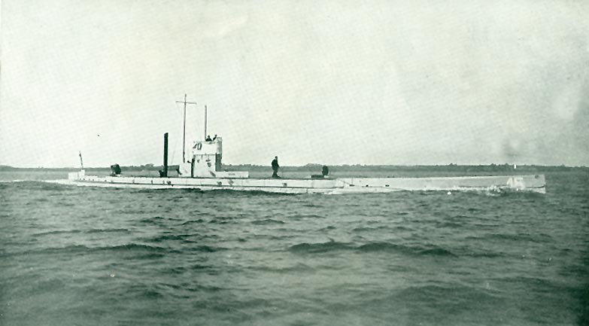
ww1medals.net

Name: Period: Date:

TECHNOLOGY OF WORLD WAR I

Name & Description of Technology: | How could this new technology change how wars were fought?
Advantages of new technology: | Disadvantages of new technology:
Name & Description of Technology: | How could this new technology change how wars were fought?
Advantages of new technology: | Disadvantages of new technology:
Name & Description of Technology: | How could this new technology change how wars were fought?
Advantages of new technology: | Disadvantages of new technology:
Name & Description of Technology: | How could this new technology change how wars were fought?
Advantages of new technology: | Disadvantages of new technology:

Name & Description of Technology: | How could this new technology change how wars were fought?
Advantages of new technology: | Disadvantages of new technology:
Name & Description of Technology: | How could this new technology change how wars were fought?
Advantages of new technology: | Disadvantages of new technology:
Name & Description of Technology: | How could this new technology change how wars were fought?
Advantages of new technology: | Disadvantages of new technology:

Summary: Were the new technologies beneficial in fighting the War? If so, in what ways? If not, support your answer. Use SPECIFIC examples from the pictures above to support your claim.
____________________________________________________________________________________________________________________________________________________________________________________________________________________________________________________________________________________________________________________________________________________________________________________________________________________________________________________________________________________________________________________________________________________________________________________________________________________________________________________________________________________________________________________________________________________________________________________________________________________________________________________________________________________________________________________________________

